**Creating Grey Market Vehicles**

ZTC_WTY_GREY_VEH: Upload Grey Market Vehicles

Got to transactions code: ZTC_WTY_GREY_VEH

* Enter Sales organisation”6410”
* And choose the files to upload

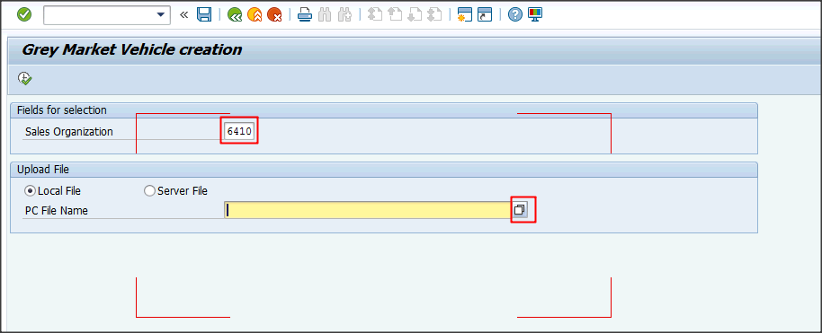

Select the file and click open (sample attached below)

|  |  |  |
| --- | --- | --- |
| ZENG_NUMB | Engine No. (From Velo, Vehicle Data>General Data Tab) |  |
| ZTRNM_NUMB | Transmission No. (From Velo, Vehicle Data>General Data Tab) |  |
| WARR_CODE | Warranty Code(From Velo, Configuration Tab) |  |
| MDL_FAMILY | MDL_FAMILY(From Velo, Configuration Tab) |  |
| GMDL |  |  |



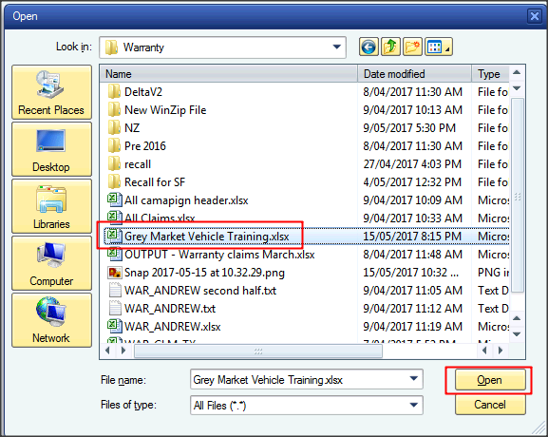

Once the file is selected click execute

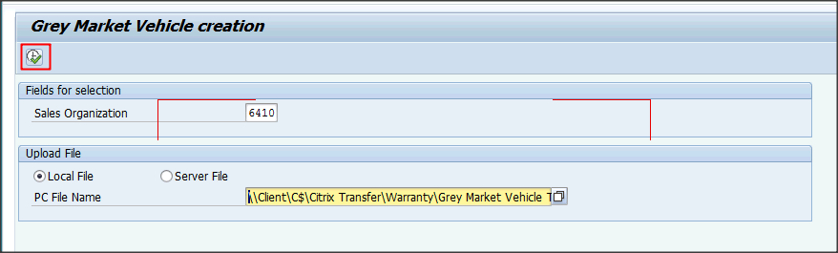

The file loaded contained three vehicles. Look for the highlighted message for each of the vehicles you intend on creating.

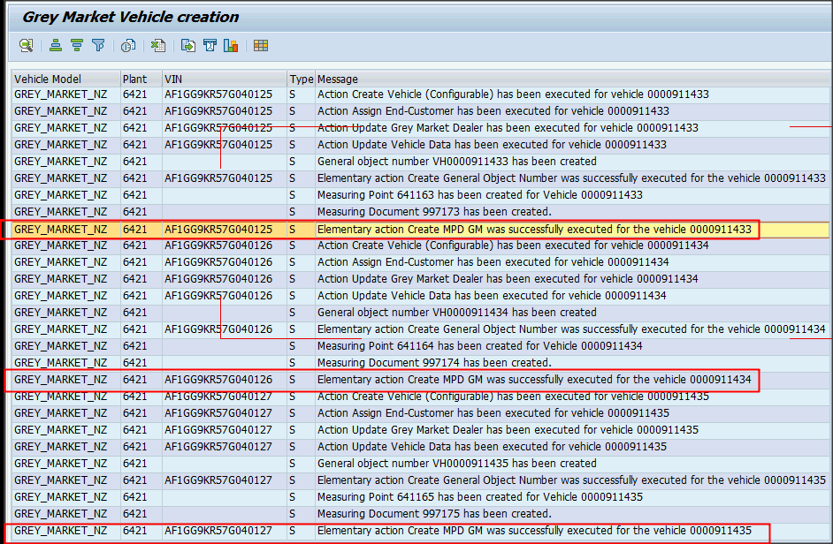

This report can be exported to excel and reconciled there

Click list > Export > Spreadsheet

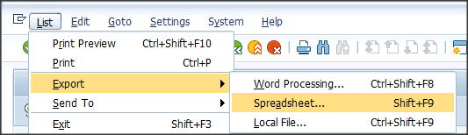

Choose the below format and click the tick

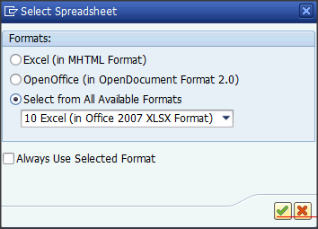

Save the files and open

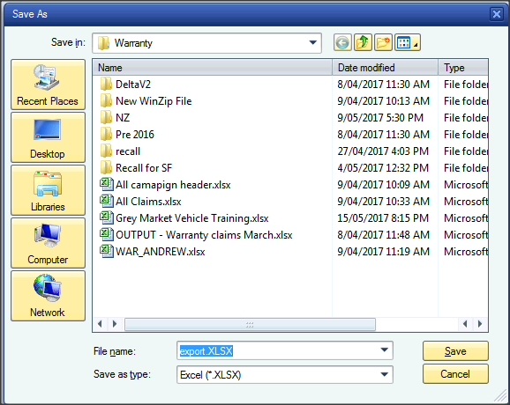

If a warranty claim is expected on the vehicle you must create the warranty

Go to transaction VELO

Ensure to choose VIN and then enter the VIN in the field to right

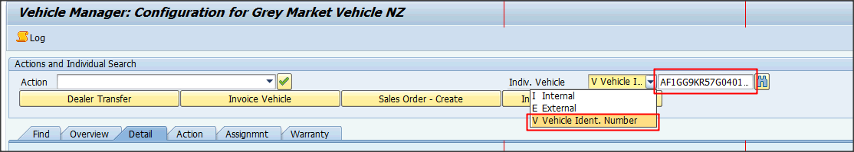

Run actions ZYVH by selected it in the drop down below and click the tick to right of the drop down box

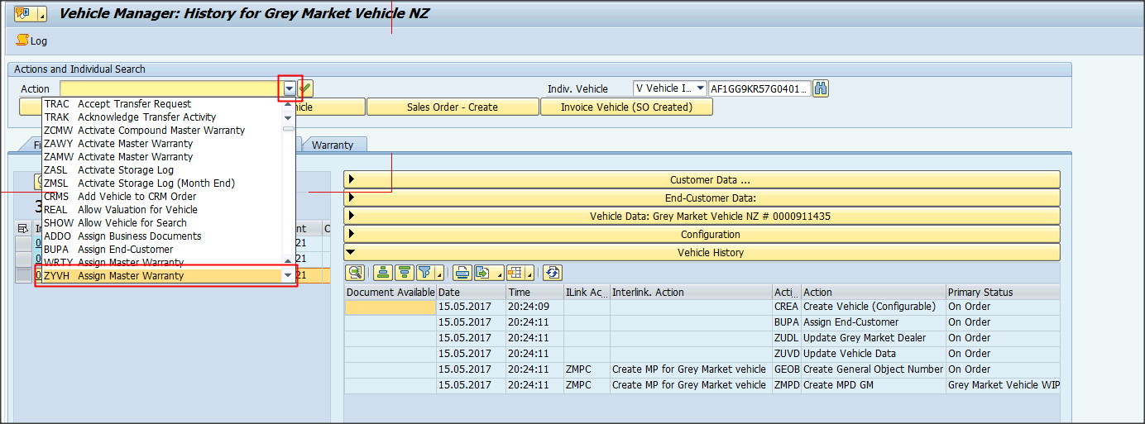

Enter the below and click execute action

* Enter Warranty type 201
* Choose the start date
* Policy provider and reason code are text fields for information only

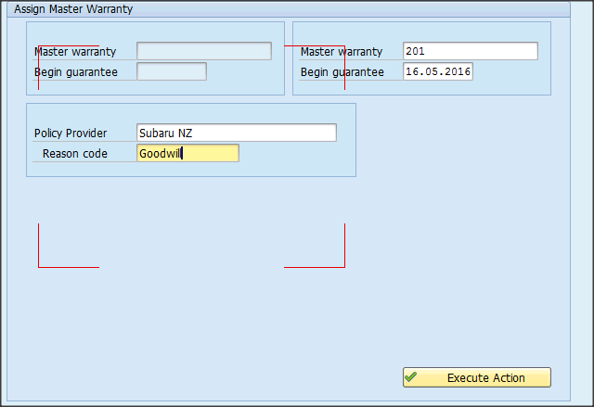

You will receive this message in the bottom right if it’s successful

